**PL/SQL**

* **USING BEGIN AND END:**

BEGIN

DBMS_OUTPUT.PUT_LINE('PL/SQL IS EASY');

END;

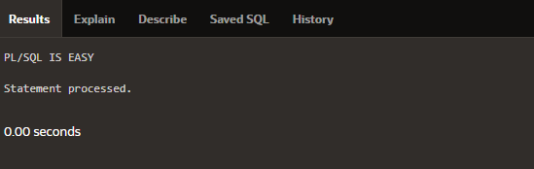

* **USING DECLARE:**

DECLARE

V_DATE DATE:=SYSDATE;

BEGIN

DBMS_OUTPUT.PUT_LINE(V_DATE);

END;

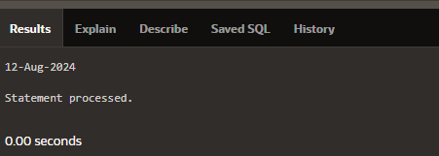

* **EXCEPTION:**

DECLARE

AGE NUMBER(10);

LAST_NAME VARCHAR2(20);

BEGIN

SELECT AGE, LAST_NAME

INTO AGE, LAST_NAME

FROM COP3

WHERE LAST_NAME = 'DIVYA';

DBMS_OUTPUT.PUT_LINE('EMPLOYEE OF THE MONTH IS: ' || AGE || ' ' || LAST_NAME || '.');

EXCEPTION

WHEN TOO_MANY_ROWS THEN

DBMS_OUTPUT.PUT_LINE('Your SELECT statement retrieved multiple rows. Consider using a cursor or changing the search criteria.');

WHEN NO_DATA_FOUND THEN

DBMS_OUTPUT.PUT_LINE('No employee found with the last name DIVYA.');

WHEN OTHERS THEN

DBMS_OUTPUT.PUT_LINE('An unexpected error occurred: ' || SQLERRM);

END;

/

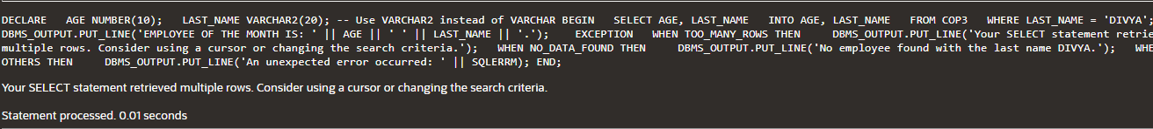

* **ADDITION OF TWO NUMBER:**

DECLARE

a integer := 10;

b integer := 20;

c integer;

f real;

BEGIN

c := a + b;

dbms_output.put_line('Value of c: ' || c);

f := 70.0/3.0;

dbms_output.put_line('Value of f: ' || f);

END;

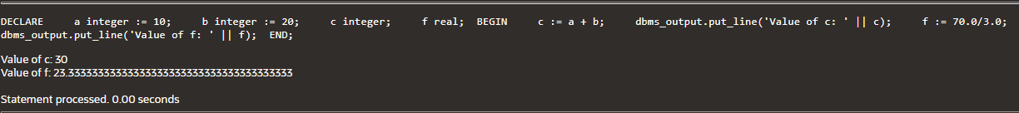

* **FIND THE RADIUS,DIAMETER,CIRCUMFRENEC AND AREA OF CIRCLE:**

DECLARE

-- constant declaration

pi constant number := 3.141592654;

-- other declarations

radius number(5,2);

dia number(5,2);

circumference number(7, 2);

area number (10, 2);

BEGIN

-- processing

radius := 9.5;

dia := radius * 2;

circumference := 2.0 * pi * radius;

area := pi * radius * radius;

-- output

dbms_output.put_line('Radius: ' || radius);

dbms_output.put_line('Diameter: ' || dia);

dbms_output.put_line('Circumference: ' || circumference);

dbms_output.put_line('Area: ' || area);

END;

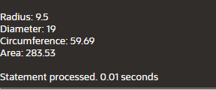

* **FIND THE GREATER NUMBER IN GIVEN TWO NUMBER:**

DECLARE

a INTEGER;

b INTEGER;

BEGIN

a := 10;

b := 20;

IF (a >= b) THEN

DBMS_OUTPUT.PUT_LINE('A IS GRETAER NUMBER');

ELSE

DBMS_OUTPUT.PUT_LINE('B IS GREATER NUMBER');

END IF;

END;



* **Count the word and character:**

DECLARE

str VARCHAR2(40) := 'Tutorials Point';

nchars NUMBER(4) := 0;

nwords NUMBER(4) := 1;

s CHAR(1);

BEGIN

FOR i IN 1..Length(str) LOOP

s := Substr(str, i, 1);

nchars := nchars + 1;

IF s = ' ' THEN

nwords := nwords + 1;

END IF;

END LOOP;

dbms_output.Put_line('Count of characters is: ' || nchars);

dbms_output.Put_line('Count of words are: ' || nwords);

END;

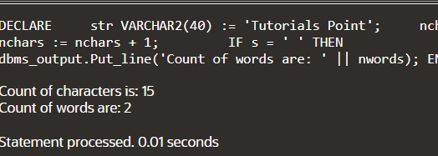

* **Sum of the number:**

DECLARE

sum_of_numbers NUMBER := 0;

BEGIN

FOR i IN 1..10 LOOP

sum_of_numbers := sum_of_numbers + i;

END LOOP;

DBMS_OUTPUT.PUT_LINE('Sum of numbers from 1 to 10 is ' || sum_of_numbers);

END;

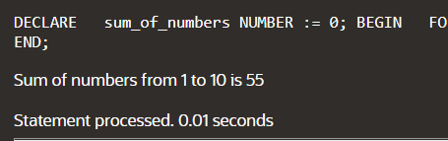

* **PRINT THR EVEN NUMBER:**

DECLARE

i NUMBER;

BEGIN

FOR i IN 1..20 LOOP

IF MOD(i, 2) = 0 THEN

DBMS_OUTPUT.PUT_LINE(i);

END IF;

END LOOP;

END;

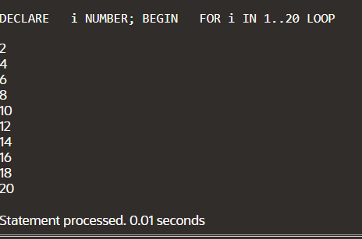

* **ARRAY CONCEPT:**

DECLARE

type namesarray IS VARRAY(5) OF VARCHAR2(10);

type grades IS VARRAY(5) OF INTEGER;

names namesarray;

marks grades;

total integer;

BEGIN

names := namesarray('Kavita', 'Pritam', 'Ayan', 'Rishav', 'Aziz');

marks:= grades(98, 97, 78, 87, 92);

total := names.count;

dbms_output.put_line('Total '|| total || ' Students');

FOR i in 1 .. total LOOP

dbms_output.put_line('Student: ' || names(i) || '

Marks: ' || marks(i));

END LOOP;

END;

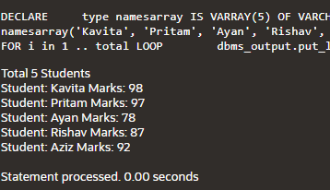

* **TO IDENTIFYING THE GRADE BASED ON MARKS:**

DECLARE

TYPE namesarray IS VARRAY(5) OF VARCHAR2(10);

TYPE grades IS VARRAY(5) OF INTEGER;

names namesarray;

marks grades;

total INTEGER;

BEGIN

names := namesarray('Kavita', 'Pritam', 'Ayan', 'Rishav', 'Aziz');

marks := grades(98, 97, 78, 87, 92);

total := names.count;

dbms_output.put_line('Total ' || total || ' Students');

FOR i IN 1 .. total LOOP

dbms_output.put_line('Student: ' || names(i) || ' Marks: ' || marks(i));

IF marks(i) > 95 THEN

dbms_output.put_line('S GRADE');

ELSIF marks(i) > 85 THEN

dbms_output.put_line('A GRADE');

ELSIF marks(i) > 75 THEN

dbms_output.put_line('B GRADE');

ELSE

dbms_output.put_line('FAIL');

END IF;

END LOOP;

END;

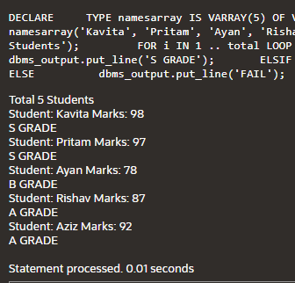

* **COUNT THE EVEN AND ODD NUMBER:**

GDECLARE

v_start NUMBER := 1; -- Start of the range

v_end NUMBER := 10; -- End of the range

v_even_count NUMBER := 0;

v_odd_count NUMBER := 0;

BEGIN

FOR i IN v_start..v_end LOOP

IF MOD(i, 2) = 0 THEN

DBMS_OUTPUT.PUT_LINE('Even: ' || i);

v_even_count := v_even_count + 1;

ELSE

DBMS_OUTPUT.PUT_LINE('Odd: ' || i);

v_odd_count := v_odd_count + 1;

END IF;

END LOOP;

DBMS_OUTPUT.PUT_LINE('Total Even Numbers: ' || v_even_count);

DBMS_OUTPUT.PUT_LINE('Total Odd Numbers: ' || v_odd_count);

END;

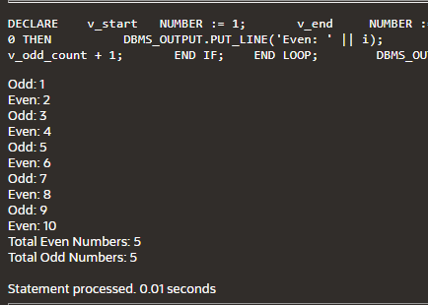

* **COUNT THE EVEN AND ODD NUMBER IN GIVEN ARRAY:**

DECLARE

TYPE V_NUMBER IS VARRAY(8) OF INTEGER(10);

v_numbers V_NUMBER := V_NUMBER(2, 3, 1, 4, 6, 5, 7, 9);

v_even_count NUMBER := 0;

v_odd_count NUMBER := 0;

BEGIN

FOR i IN 1..v_numbers.COUNT LOOP

IF MOD(v_numbers(i), 2) = 0 THEN

DBMS_OUTPUT.PUT_LINE('Even: ' || v_numbers(i));

v_even_count := v_even_count + 1;

ELSE

DBMS_OUTPUT.PUT_LINE('Odd: ' || v_numbers(i));

v_odd_count := v_odd_count + 1;

END IF;

END LOOP;

DBMS_OUTPUT.PUT_LINE('Total Even Numbers: ' || v_even_count);

DBMS_OUTPUT.PUT_LINE('Total Odd Numbers: ' || v_odd_count);

END;

* **COUNT THE EVEN AND ODD NUMBBER WITHOUT USING ARRAY FUNCTION:**

DECLARE

v_number NUMBER := 123456789;

v_digit NUMBER;

v_num NUMBER;

v_even_count NUMBER := 0;

v_odd_count NUMBER := 0;

BEGIN

v_num := v_number;

WHILE v_num > 0 LOOP

v_digit := MOD(v_num, 10);

IF MOD(v_digit, 2) = 0 THEN

v_even_count := v_even_count + 1;

ELSE

v_odd_count := v_odd_count + 1;

END IF;

v_num := FLOOR(v_num / 10);

END LOOP;

DBMS_OUTPUT.PUT_LINE('Even digits count: ' || v_even_count);

DBMS_OUTPUT.PUT_LINE('Odd digits count: ' || v_odd_count);

END;

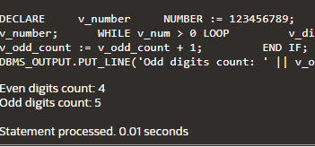

* **PROCEDURE:**
* **FIND THE MINIMUM NUMBER BETWEEN TWO NUMBER:**

DECLARE

a number;

b number;

c number;

PROCEDURE findMin(x IN number, y IN number, z OUT number) IS

BEGIN

IF x < y THEN

z:= x;

ELSE

z:= y;

END IF;

END;

BEGIN

a:= 23;

b:= 45;

findMin(a, b, c);

G dbms_output.put_line(' Minimum of (23, 45) : ' || c);

END;

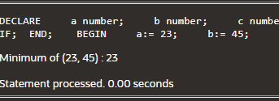

* **CALCULATOR WITHOUT USING FUNCTION:**

DECLARE

PROCEDURE calculator(p_num1 IN NUMBER, p_num2 IN NUMBER, p_operation IN CHAR) IS

v_result NUMBER;

BEGIN

IF p_operation = '+' THEN

v_result := p_num1 + p_num2;

ELSIF p_operation = '-' THEN

v_result := p_num1 - p_num2;

ELSIF p_operation = '*' THEN

v_result := p_num1 * p_num2;

ELSIF p_operation = '/' THEN

IF p_num2 <> 0 THEN

v_result := p_num1 / p_num2;

ELSE

DBMS_OUTPUT.PUT_LINE('Error: Division by zero');

RETURN;

END IF;

ELSE

DBMS_OUTPUT.PUT_LINE('Error: Invalid operation');

RETURN;

END IF;

DBMS_OUTPUT.PUT_LINE('Result: ' || v_result);

END;

BEGIN

calculator(10, 5, '+');

calculator(10, 5, '-');

calculator(10, 5, '*');

calculator(10, 5, '/');

calculator(10, 0, '/');

calculator(10, 5, '%');

END;

* **CALCULATOR WITH USING SWITCH CASE:**

DECLARE

p_num1 number;

p_num2 number;

v_result number;

PROCEDURE calculator(p_num1 IN NUMBER, p_num2 IN NUMBER, p_operation IN CHAR) IS

v_result NUMBER;

BEGIN

CASE p_operation

WHEN '+' THEN

v_result := p_num1 + p_num2;

WHEN '-' THEN

v_result := p_num1 - p_num2;

WHEN '*' THEN

v_result := p_num1 * p_num2;

WHEN '/' THEN

IF p_num2 <> 0 THEN

v_result := p_num1 / p_num2;

ELSE

DBMS_OUTPUT.PUT_LINE('Error: Division by zero');

RETURN;

END IF;

ELSE

DBMS_OUTPUT.PUT_LINE('Error: Invalid operation');

RETURN;

END CASE;

DBMS_OUTPUT.PUT_LINE('Result: ' || v_result);

END;

BEGIN

calculator(10, 5, '+');

calculator(10, 5, '-');

calculator(10, 5, '*');

calculator(10, 5, '/');

calculator(10, 0, '/');

calculator(10, 5, '%');

END;

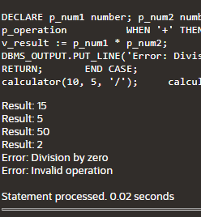

* **FACTORIAL USING FUNCTION:**

DECLARE

num number;

factorial number;

FUNCTION fact(x number)

RETURN number

IS

f number;

BEGIN

IF x=0 THEN

f := 1;

ELSE

f := x * fact(x-1);

END IF;

RETURN f;

END;

BEGIN

num:= 6;

factorial := fact(num);

dbms_output.put_line(' Factorial '|| num || ' is ' || factorial);

END;

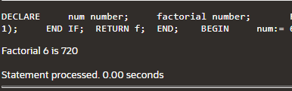

* **TO FIND THE MAXIMUM NUMBER IN GIVEN NUMBER WITH USING FUNCTION:**

DECLARE

a number;

b number;

c number;

FUNCTION findMax(x IN number, y IN number)

RETURN number

IS

z number;

BEGIN

IF x > y THEN

z:= x;

ELSE

Z:= y;

END IF;

RETURN z;

END;

BEGIN

a:= 99;

b:= 23;

c := findMax(a, b);

dbms_output.put_line(' Maximum of (23,45): ' || c);

END;

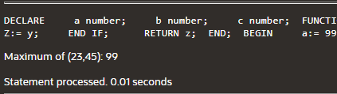\

* **FIBONACCISERIES:**

DECLARE

i NUMBER;

FUNCTION fibonacci(n NUMBER) RETURN NUMBER

IS

BEGIN

IF n <= 0 THEN

RETURN 0;

ELSIF n = 1 THEN

RETURN 1;

ELSE

RETURN fibonacci(n-1) + fibonacci(n-2);

END IF;

END fibonacci; -- add this to end the function declaration

BEGIN

FOR i IN 0..10 LOOP

DBMS_OUTPUT.PUT_LINE('Fibonacci(' || i || ') = ' || fibonacci(i));

END LOOP;

END;

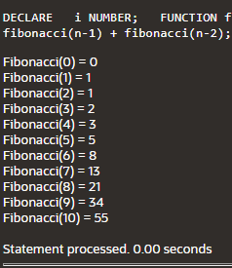

* **IMPLICITY:**

DECLARE

total_rows number(2);

BEGIN

UPDATE COP3

SET AGE = AGE + 5;

IF sql%notfound THEN

dbms_output.put_line('no customers selected');

ELSIF sql%found THEN

total_rows := sql%rowcount;

dbms_output.put_line( total_rows || ' customers selected ');

END IF;

END;

**BEFORE TABLE:**

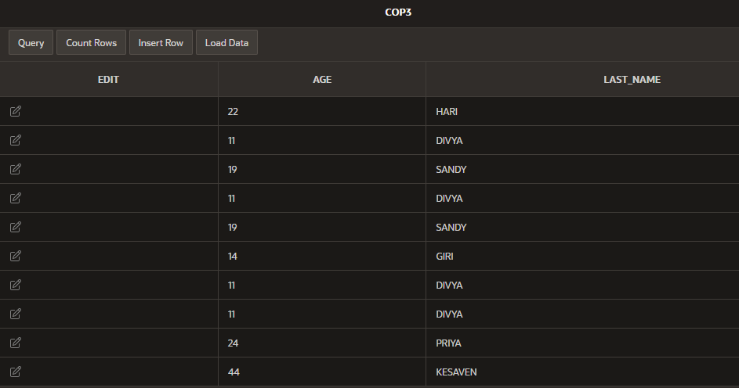

**OUTPUT:**

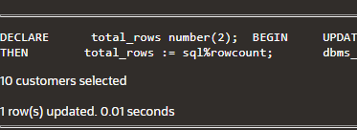

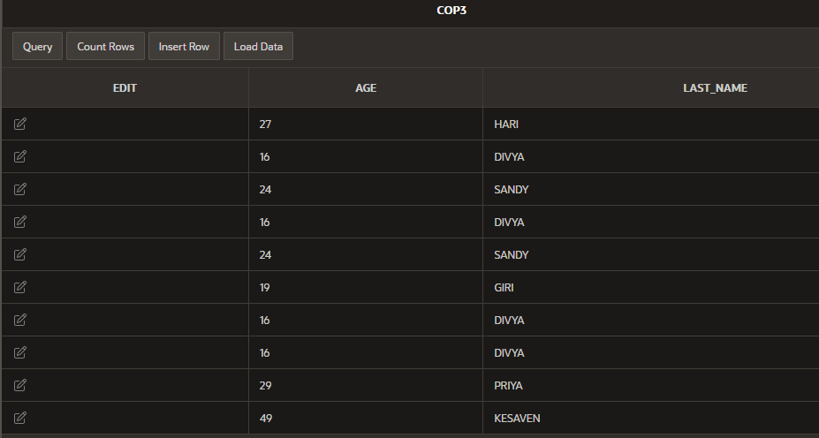

* **EXPLICITE:**

DECLARE

ID (link unavailable)%TYPE;

L_NAME DD.L_NAME%TYPE;

CURSOR DD_CUR IS

SELECT ID, L_NAME

FROM DD;

BEGIN

OPEN DD_CUR;

LOOP

FETCH DD_CUR INTO ID, L_NAME;

EXIT WHEN DD_CUR%NOTFOUND;

DBMS_OUTPUT.PUT_LINE(ID || ' ' || L_NAME);

END LOOP;

CLOSE DD_CUR;

END;